**ASSIGNMENT #02**

**NAME: BASHARAT HUSSAIN**

**ROLL NO:17P6102**

**SUBJECT: DATABASE SYSTEMS**

**SECTION: 6b**

**TEACHER: MISS.SAFIA FATIMA**

**Dated: 5/2/2021**

**1.Views**

**Question #01**

Let’s say this bank has some authorization requirements which restricts employees of bank from seeing records or information about officers who are also customers. So create a view, named ‘customer_info’ which lets the employees see all customers and their information except those customers who are officers.

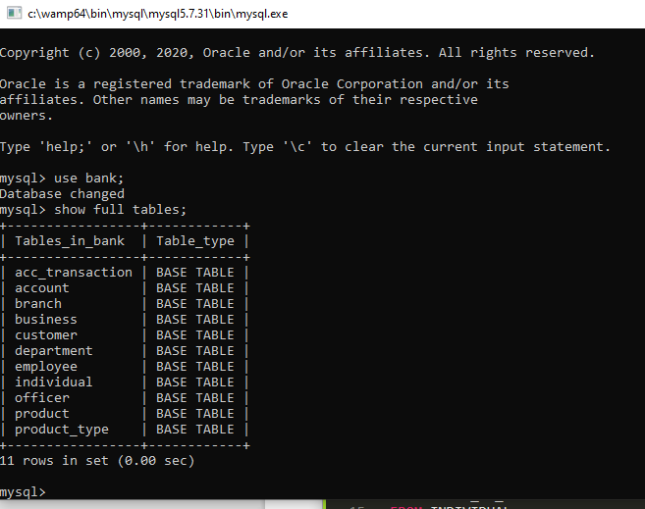

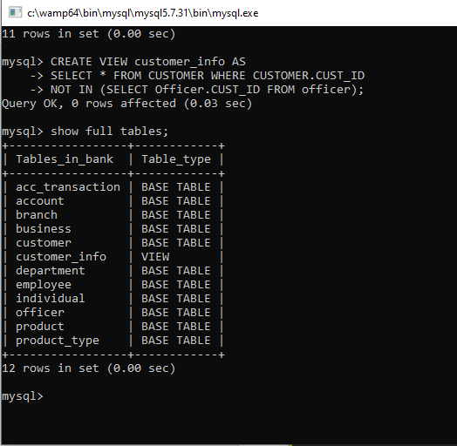

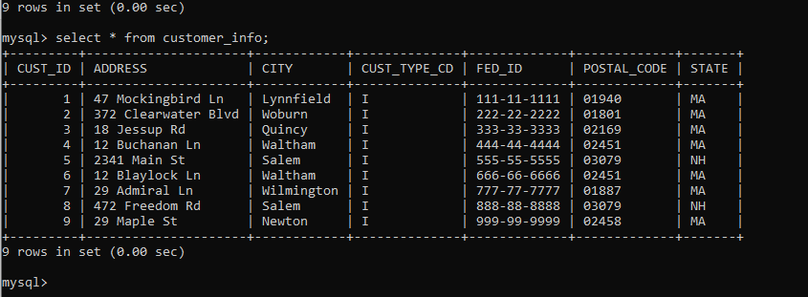

**Question #02**

Create a view named ‘individual_info’ which shows all information of individuals except their customer Ids and also lists how much balance each indivual has in his/her account.

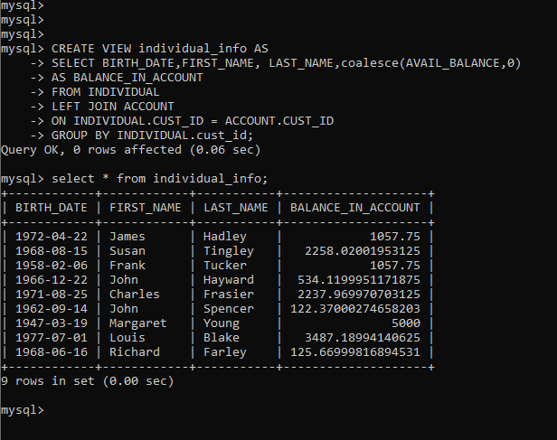

**Question #03**

Create a view named ‘customer_accounts’ which shows information of only those accounts which have PRODUCT_TYPE_CD as ‘Account’ and which have pending balanace less than ‘2000’

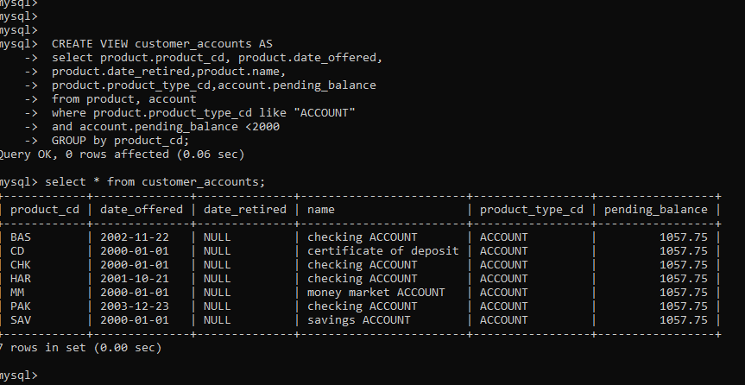

**Question #04**

Create a view named ‘senior_views’ which presents all information about employees with start dates in 2002 or after it. This view shall also include information about the branches that these employees are stationed to.

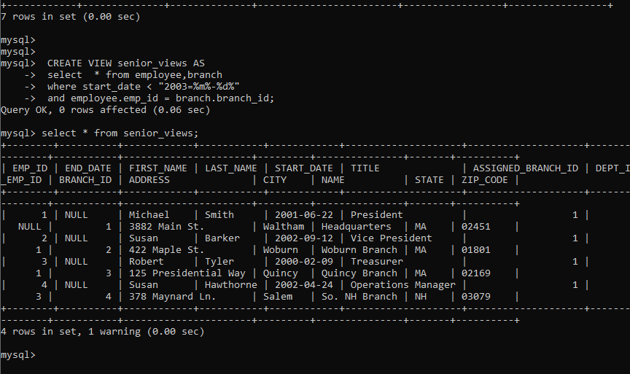

**2. User Roles**

**Question #01**

You need to now create a user which has the name set as your roll number and assign any password of your liking. Let’s say a user is created with name ‘P180058’ and password ‘fast123’. Note: You MUST use your own roll number as user name. Now, grant this user that you have created, the permissions to run SELECT, INSERT, UPDATE AND DELETE commands against all tables. You need to then issue 3 commands each for INSERT, UPDATE, and DELETE, for the tables of any 5 tables.

CREATE USER 'P176102'@'localhost'IDENTIFIED BY 'fast123';

GRANT SELECT,INSERT,UPDATE,DELETE ON bank.acc_transaction TO'P176102'@'localhost';

GRANT SELECT,INSERT,UPDATE,DELETE ON bank.account TO'P176102'@'localhost';

GRANT SELECT,INSERT,UPDATE,DELETE ON bank.branch TO'P176102'@'localhost';

GRANT SELECT,INSERT,UPDATE,DELETE ON bank.business TO'P176102'@'localhost';

GRANT SELECT,INSERT,UPDATE,DELETE ON bank.customer TO'P176102'@'localhost';

GRANT SELECT,INSERT,UPDATE,DELETE ON bank.department TO'P176102'@'localhost';

GRANT SELECT,INSERT,UPDATE,DELETE ON bank.employee TO'P176102'@'localhost';

GRANT SELECT,INSERT,UPDATE,DELETE ON bank.individual TO'P176102'@'localhost';

GRANT SELECT,INSERT,UPDATE,DELETE ON bank.officer TO'P176102'@'localhost';

GRANT SELECT,INSERT,UPDATE,DELETE ON bank.product TO'P176102'@'localhost';

GRANT SELECT,INSERT,UPDATE,DELETE ON bank.product_type TO'P176102'@'localhost';

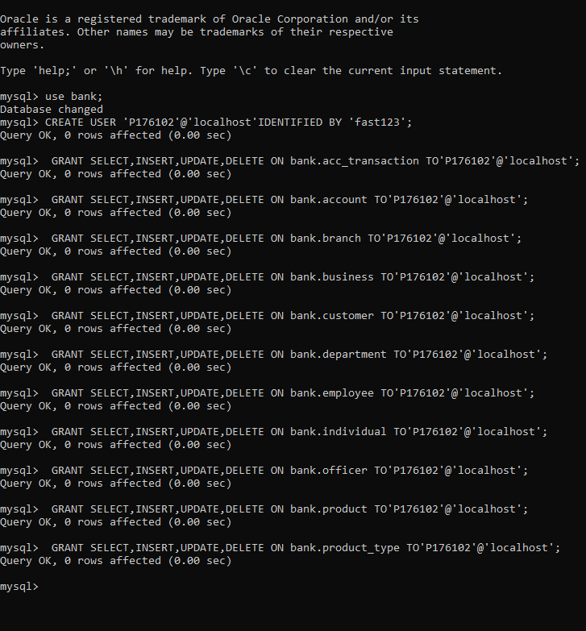

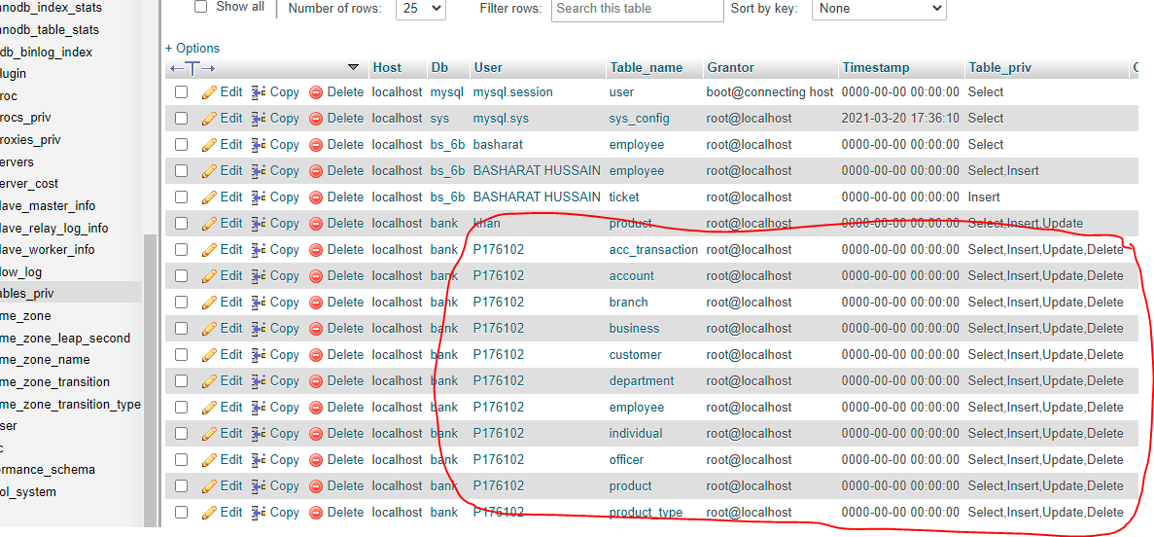

**You need to then issue 3 commands each for INSERT, UPDATE, and DELETE, for the tables of any 5 tables.**

**Insertion in BRANCH**

insert into BRANCH (branch_id, name, address, city, state, Zip_Code)

values (null, 'Headqters', '382 Main St.', 'ltham', 'MA', '451');

insert into BRANCH (branch_id, name, address, city, state, Zip_Code)

values (null, 'Headrters', '3882 Ma St.', 'Wtham', 'MA', '024');

insert into BRANCH (branch_id, name, address, city, state, Zip_Code)

values (null, 'Head', '32 Main St.', 'Walt', 'MA', '024');

**insertion in Department**

insert into DEPARTMENT (dept_id, name)values (null, 'Operons');

insert into DEPARTMENT (dept_id, name)values (null, 'Operas');

insert into DEPARTMENT (dept_id, name)values (null, 'Otions');

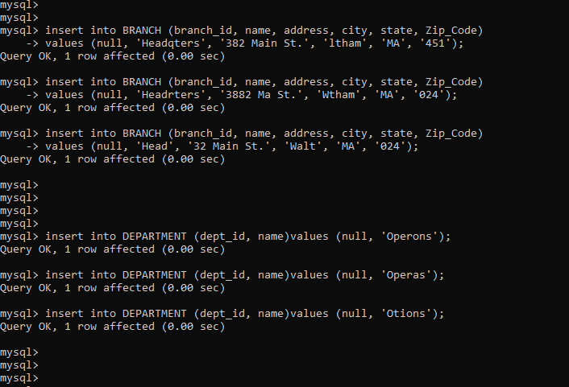

**insertion in PRODUCT_TYPE**

insert into PRODUCT_TYPE (product_type_cd, name)

values ('ACCOUNT1','Customer Accounts');

insert into PRODUCT_TYPE (product_type_cd, name)

values ('ACCOUNT2','Customer Accounts');

insert into PRODUCT_TYPE (product_type_cd, name)

values ('ACCOUNT3','Customer Accounts');

**insertion in CUSTOMER**

insert into CUSTOMER (cust_id, fed_id, cust_type_cd,

address, city, state, postal_code)

values (null, '04-1111111', 'B', '7 Industrial Way', 'Salem', 'NH', '20309');

insert into CUSTOMER (cust_id, fed_id, cust_type_cd,

address, city, state, postal_code)

values (null, '04-1111111', 'B', '7 Industrial Way', 'Salem', 'NH', '01309');

insert into CUSTOMER (cust_id, fed_id, cust_type_cd,

address, city, state, postal_code)

values (null, '04-1111111', 'B', '7 Industrial Way', 'Salem', 'NH', '03059');

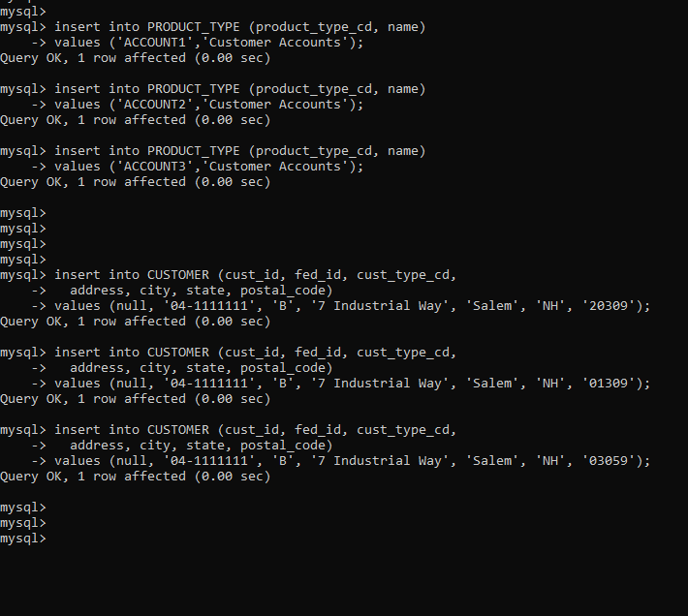

**insertion in PRODUCT**

insert into PRODUCT (product_cd, name, product_type_cd, date_offered)

values ('CHK1','checking ACCOUNT','ACCOUNT1','2000-01-01');

insert into PRODUCT (product_cd, name, product_type_cd, date_offered)s

values ('SAV1','savings ACCOUNT','ACCOUNT2','2000-01-01');

insert into PRODUCT (product_cd, name, product_type_cd, date_offered)

values ('MM1','money market ACCOUNT','ACCOUNT3','2000-01-01');

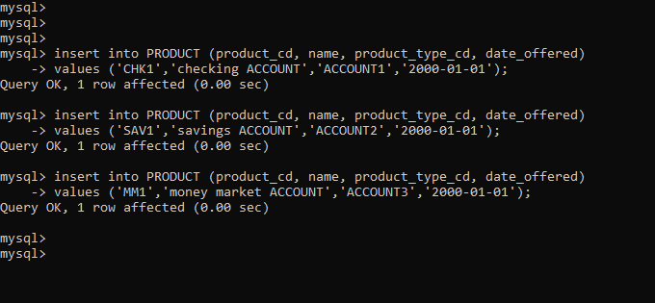

**UPDATE in BRANCH**

update BRANCH set name = 'Headqters1'

WHERE name = 'Headqters';

update BRANCH set name = 'Headrters1'

WHERE name = 'Headrters';

update BRANCH set name = 'Head1'

WHERE name = 'Head';

**UPDATE in DEPARTMENT**

update DEPARTMENT set name = 'Operons1'

WHERE name = 'Operons';

update DEPARTMENT set name = 'Operas2'

WHERE name = 'Operas';

update DEPARTMENT set name = 'Otions3'

WHERE name = 'Otions';

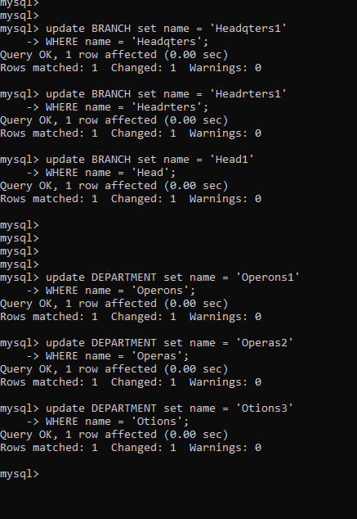

**UPDATE in PRODUCT_TYPE**

update PRODUCT_TYPE set name = 'Customer1'

WHERE product_type_cd = 'ACCOUNT1';

update PRODUCT_TYPE set name = 'Customer2'

WHERE product_type_cd = 'ACCOUNT2';

update PRODUCT_TYPE set name = 'Customer3'

WHERE product_type_cd = 'ACCOUNT3';

**UPDATE in CUSTOMER**

update CUSTOMER set cust_type_cd = '20000'

WHERE cust_type_cd = '20309';

update CUSTOMER set cust_type_cd = '30000'

WHERE cust_type_cd = '01309';

update CUSTOMER set cust_type_cd = '40000'

WHERE cust_type_cd = '03059';

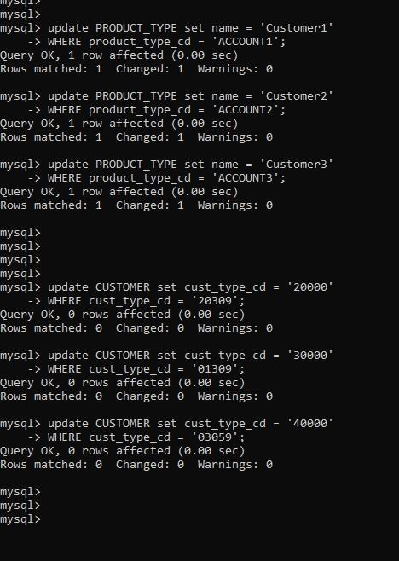

**UPDATE in PRODUCT**

update PRODUCT set date_offered = '2001-10-21'

WHERE product_cd = 'CHK1';

update product set date_offered = '2002-11-22'

WHERE product_cd = 'SAV1';

update product set date_offered = '2003-12-23'

WHERE product_cd = 'MM1';

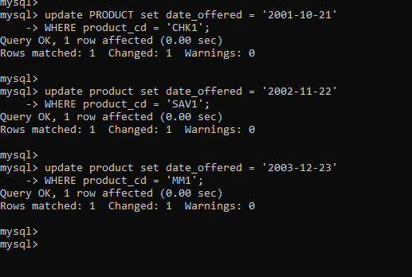

**DELETE in BRANCH**

DELETE FROM BRANCH WHERE name = 'Headqters1';

DELETE FROM BRANCH WHERE name = 'Headrters1';

DELETE FROM BRANCH WHERE name = 'Head1';

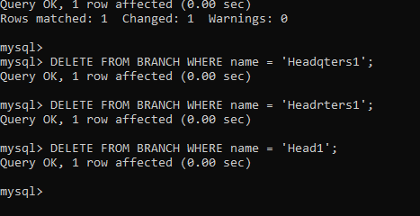

**DELETE in DEPARTMENT**

DELETE FROM DEPARTMENT WHERE name = 'Operons1';

DELETE FROM DEPARTMENT WHERE name = 'Operas2';

DELETE FROM DEPARTMENT WHERE name = 'Otions3';

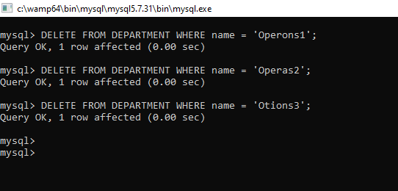

**DELETE in PRODUCT_TYPE**

DELETE FROM PRODUCT_TYPE WHERE name = 'Customer1';

DELETE FROM PRODUCT_TYPE WHERE name = 'Customer2';

DELETE FROM SPRODUCT_TYPE WHERE name = 'Customer3';

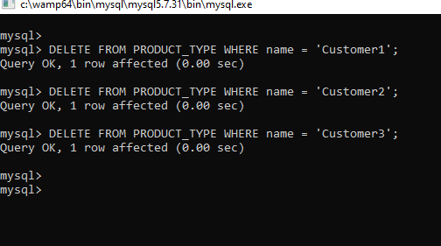

**DELETE in CUSTOMER**

DELETE FROM CUSTOMER WHERE cust_type_cd = '20000';

DELETE FROM CUSTOMER WHERE cust_type_cd = '30000';

DELETE FROM CUSTOMER WHERE cust_type_cd = '40000';

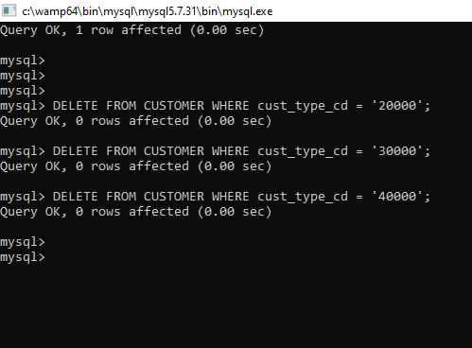

**DELETE in PRODUCT**

DELETE FROM PRODUCT WHERE date_offered = '2001-10-21';

DELETE FROM PRODUCT WHERE date_offered = '2002-11-22';

DELETE FROM PRODUCT WHERE date_offered = '2003-12-23';

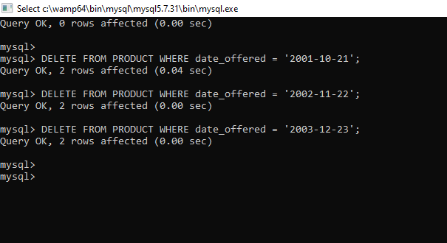

**Question #02**

Let us assume that an officer is allowed to insert and update but NOT to delete information about products. So create a new user with any name and password of your liking which can only INSERT and UPDATE on the PRODUCT table. Issue 3 commands of INSERT and 3 commands of UPDATE by this user on the Product table.

First of all, we open root user

and use database “bank”

then we create new user named as ‘khan’ with password ‘12345’.

The we give INSERT, UPDATE privilege to this user in PRODUCT table.

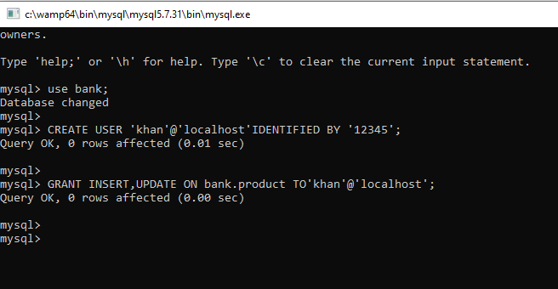

Here we can see the results.

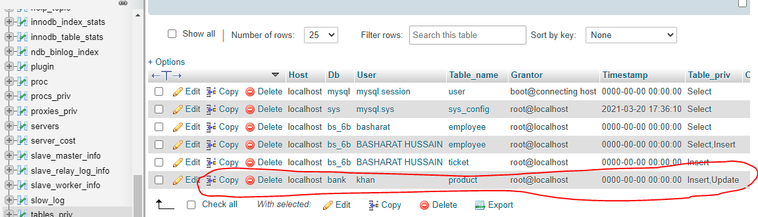

Now we open with new user named as Khan and enter the Password

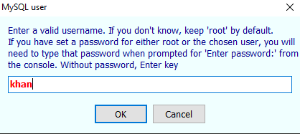

Here we see database named as bank and tis table in the bank named as PRODUCT.

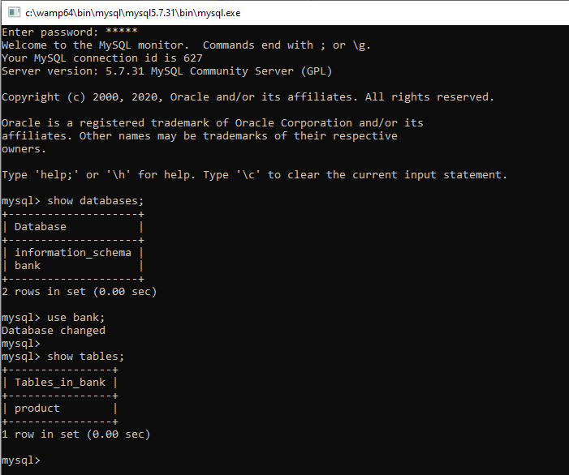

Now insert three commands in to this table of bank database.

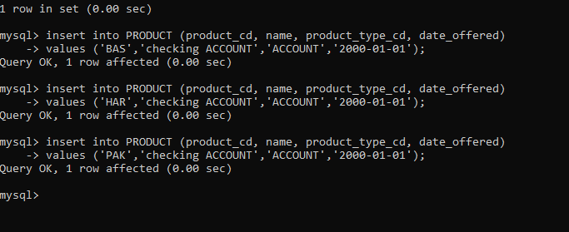

Now we open root console and see the results. Here we can easily see insertion is completely successfully in the product table of bank database.

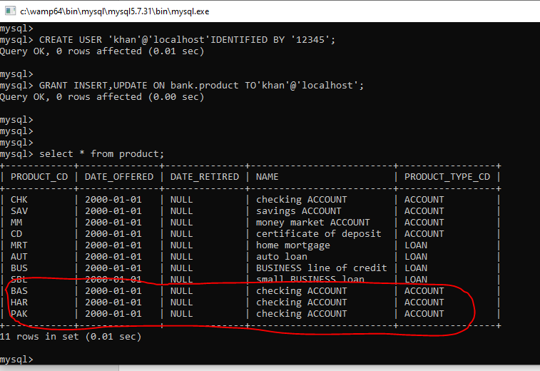

For update:

Now we open root user and give Select Privilege to this table of bank database.

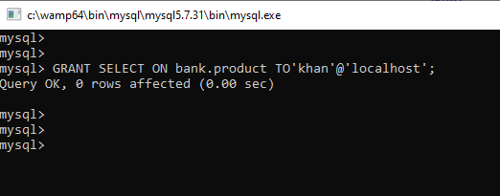

Now we can easily update this table by using below queries.

Here are three update queries.

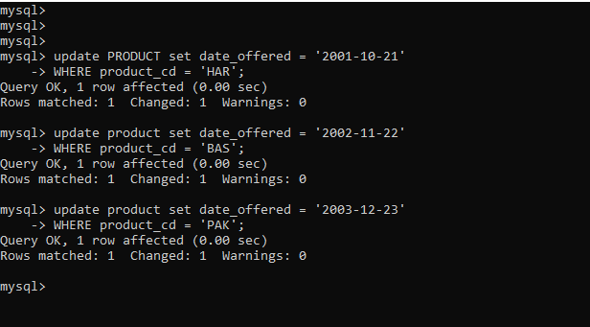

Now we can see the results. Here we can easily see “updation” is completely successfully in the product table of bank database.

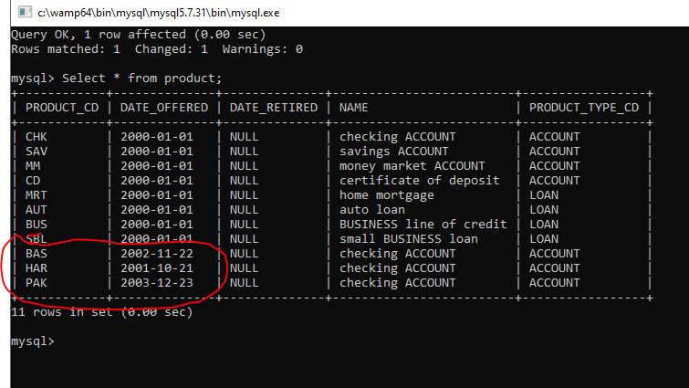

<<<<<<<<<<<<<<<<<<<<<THE END>>>>>>>>>>>>>>>>>>>>>>>